EXPERIMENT 4
Aim:
To detect and handle outliers in a dataset using the IQR (Interquartile Range) method and visualize the data distribution.
Procedure:
- Generated a random integer array of 16 values between 1 and 100.
- Calculated mean and percentiles (25th, 50th, 75th, and 100th) of the array.
- Defined a function using IQR to detect outlier limits (lr and ur).
- Filtered the array to remove values outside the IQR-based bounds.
- Visualized the original and filtered arrays using Seaborn’s displot and distplot.
- Confirmed that no outliers existed as all values fell within the IQR bounds.

Code:

In [1]: import numpy as np array=np.random.randint(1,100,16) array
Out[1]: array([15, 49, 71, 43, 7, 60, 13, 59, 6, 20, 9, 92, 60, 94, 59, 39], dtype=int32)
In [2]: array.mean()
Out[2]: | np.float64(43.5)
In [3]: np.percentile(array,25)
Out[3]: | np.float64(14.5)
In [4]: np.percentile(array,50)
Out[4]: | np.float64(46.0)
In [5]: np.percentile(array,75)
Out[5]: | np.float64(60.0)
In [6]: np.percentile(array,100)
Out[6]: | np.float64(94.0)
In [7]: def outDetection(array):
sorted(array)
Q1,Q3=np.percentile(array,[25,75]) IQR=Q3-Q1 lr=Q1-(1.5*IQR) ur=Q3+(1.5*IQR) return lr,ur
In [8]: lr,ur=outDetection(array) lr,ur
Out[8]: (np.float64(-53.75), np.float64(128.25))
In [9]: import seaborn as sns %matplotlib inline sns.displot(array)
Out[9]: <seaborn.axisgrid.FacetGrid at 0x188aea49be0>
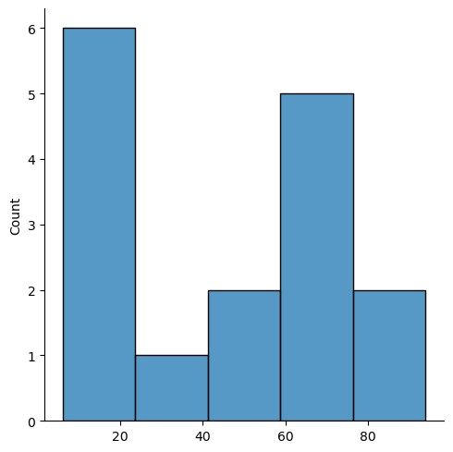
In [10]: new_array=array[(array>lr) & (array<ur)] new_array
Out[10]: array([15, 49, 71, 43, 7, 60, 13, 59, 6, 20, 9, 92, 60, 94, 59, 39], dtype=int32)
In [11]: sns.displot(new_array)
Out[11]: <seaborn.axisgrid.FacetGrid at 0x188aeb90410>

sns.distplot(new_array)
In [12]:
C:\Users\Asus\AppData\Local\Temp\ipykernel_28432\4249554950.py:1: UserWarning:
`distplot` is a deprecated function and will be removed in seaborn v0.14.0.
Please adapt your code to use either `displot` (a figure-level function with similar flexibility) or `histplot` (an axes-level function for histograms).
For a guide to updating your code to use the new functions, please see https://gist.github.com/mwaskom/de44147ed2974457ad6372750bbe5751
sns.distplot(new_array)
Out[12]: <Axes: ylabel='Density'>
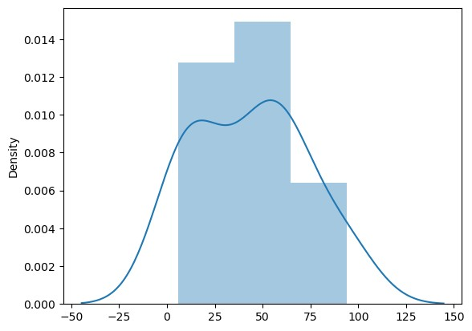
In [13]: lr1,ur1=outDetection(new_array) lr1,ur1
Out[13]: (np.float64(-53.75), np.float64(128.25))
In [14]: final_array=new_array[(new_array>lr1) & (new_array<ur1)] final_array
Out[14]: array([15, 49, 71, 43, 7, 60, 13, 59, 6, 20, 9, 92, 60, 94, 59, 39], dtype=int32)
In [15]: sns.displot(final_array)
Out[15]: <seaborn.axisgrid.FacetGrid at 0x188afc065d0>

sns.distplot(final_array)
In [16]:
C:\Users\Asus\AppData\Local\Temp\ipykernel_28432\209491988.py:1: UserWarning:
`distplot` is a deprecated function and will be removed in seaborn v0.14.0.
Please adapt your code to use either `displot` (a figure-level function with similar flexibility) or `histplot` (an axes-level function for histograms).
For a guide to updating your code to use the new functions, please see https://gist.github.com/mwaskom/de44147ed2974457ad6372750bbe5751
sns.distplot(final_array)
Out[16]: <Axes: ylabel='Density'>


Result :
The dataset contained no outliers, as all values were within the IQR limits.
Distribution plots confirmed a clean dataset ready for analysis.

